**Sacred Heart Parish Yea – 18th August 2024**

**20th Sunday of Ordinary Time**

**SAINTS FOR THIS WEEK: ST JOACHIM & ST ANNE**

**Recently Deceased**: We keep in our prayers all recently deceased, and those who’s anniversaries occur around this time, that they dwell for ever in God’s loving embrace. Lord Hear Us.

**Anniversaries**: Dennis Mc Carthy, Elizabeth Gower, Jodie Sier, Kath Coonan

|  |  |  |  |  |
| --- | --- | --- | --- | --- |
| **Collections last Sunday** | | |  |  |
| Presbytery Account | | $.00 | Direct Credit | $0.00 |
| Church Account  Special Contribution | | $.00  $0.00 | Direct Credit | $.00 |
| **Church Deposits by Direct Credit** | | | |  |
| **Presbytery Account –** for the welfare of bishops and priests | | | | |
| **Sacred Heart Presbytery Account** | | | |  |
| BSB | 633 000 | | Account number | 150 264 992 |
| **Church Account –** for our parish, its mission, welfare and maintenance: | | | | |
| **Sacred Heart Church Account –** for our Priests | | | |  |
| BSB | 633 000 | | Account number | 150 264 778 |

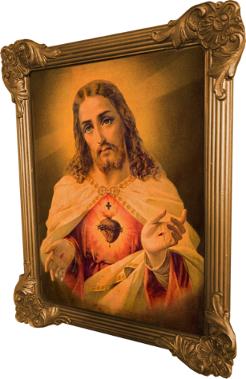**Prayers for those who are sick:** Kate Pittle, Barbara O’Donnell, Rod McKenzie, Michael Tomlinson, Tony Dwyer, Julie Mahony, Len Regan, David Heath and Monika Matteo.

**RADIO MARIA AUSTRALIA**

**Hello, we are Radio Maria Australia - a Catholic radio station bringing Christ into your every day! Broadcasting from Preston  
Our station broadcasts 24/7, with interesting and inspiring shows and podcasts, daily masses and Rosary prayers, and a variety of positive music - all to foster faith, hope and joy.  
  
You can tune in live via:** [**www.RadioMaria.org.au**](https://aus01.safelinks.protection.outlook.com/?url=http%3A%2F%2Fwww.radiomaria.org.au%2F&data=05%7C02%7CYea%40cam.org.au%7Cf490f5ac91ea46eadc2908dcbb7002c6%7C48ee20c7c8ea423c8b28f19801e34193%7C0%7C0%7C638591337094423543%7CUnknown%7CTWFpbGZsb3d8eyJWIjoiMC4wLjAwMDAiLCJQIjoiV2luMzIiLCJBTiI6Ik1haWwiLCJXVCI6Mn0%3D%7C0%7C%7C%7C&sdata=yUuSdkno4pl0N%2B6Tk9LeAKCQ2kMJK14UKFi0%2BJp74vs%3D&reserved=0) **Digital Radio: 202.928**

**Apple or Google Play App: Radio Maria Play**

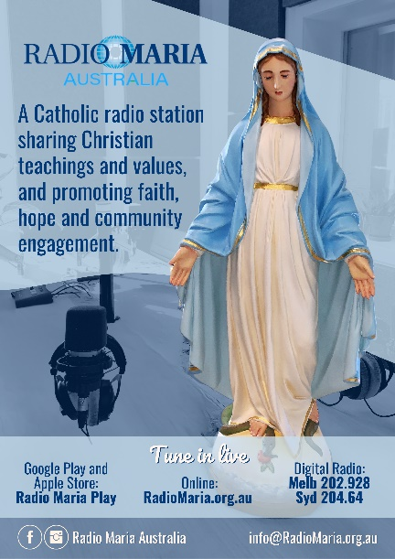

|  |  |  |  |  |  |
| --- | --- | --- | --- | --- | --- |
| **Roster** | **Readers** | | **Prayers** | **Counter** | **Flowers** |
| 11th August 2024 | J. Forde. M. Oliver | V. Hauser | | C. Jansen | M. Coonan |
| 18th August 2024 | J. Anderson M. Lockhart | E. McAleer | | A. O’Leary | J. Anderson |

**Sacred Heart Parish Yea**

Established 1890

Email: [yea@cam.org.au](mailto:yea@cam.org.au)

Phone: (03) 5899 9128

P.O. Box 61 YEA 3717

Website: www.shyea.catholic.edu.au

**Holy Mass Times**

Yea –Sunday 10:45am, Tuesday 5:00pm and Rosary, Thursday 9:00am

Alexandra – Sunday 8:45am, Wednesday 9:30am, Friday 9:00am

Parish Priest:

**Fr Jose Mathew** 0459 402 547

Secretary:   
**Sacred Heart Primary School**  
Principal: Kathryn Stuart

03 5797 2723

Reconciliation: **Fr Jose Mathew** 0459 402 547

Yea – Tuesday before Mass from 4:30pm and Sunday after Holy Mass approximately at 11:45am

Alexandra – Friday before Holy Mass and before Sunday Holy Mass from 8am